Publication: Radio Kerry
Section: Kerry Today
Date: 31 January 23

Lisa Eccles was on air with Jerry O’Sullivan on Radio Kerry on Tuesday 31st January.

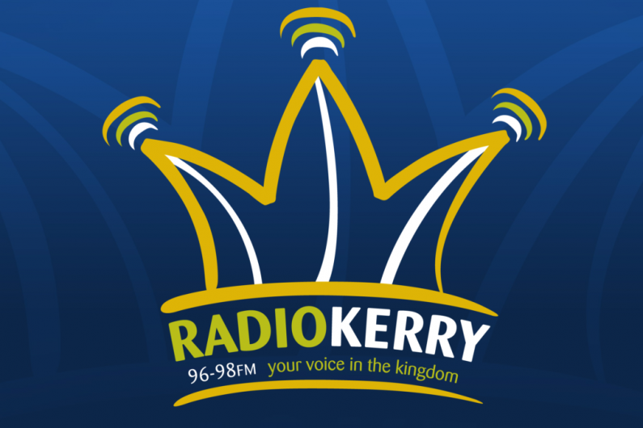

Publication: Newstalk FM
Section: Pat Kenny Show
Date: 31 January 23

Lisa Eccles was on air with Pat Kenny on Newstalk FM on Tuesday 31st January.
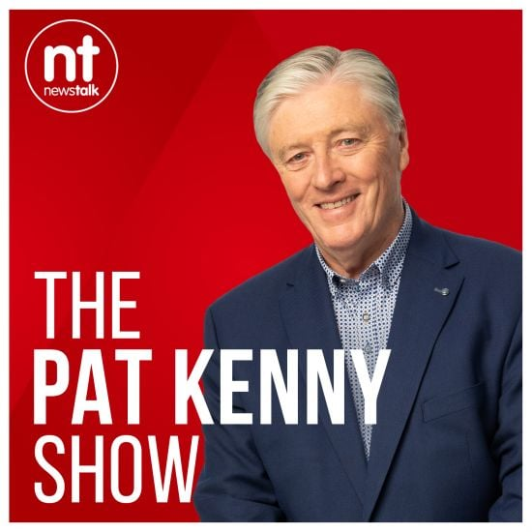
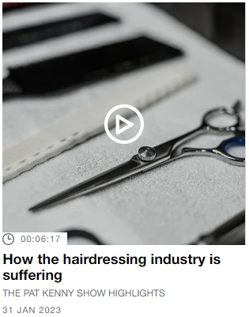
Publication: East Coast FM
Section: Morning Show
Date: 31 January 23

Lisa Eccles was on air with Declan Meehan on East Coast FM on Tuesday 31st January.

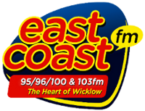

Publication: RTÉ News Online
Section: News
Date: 31 January 23
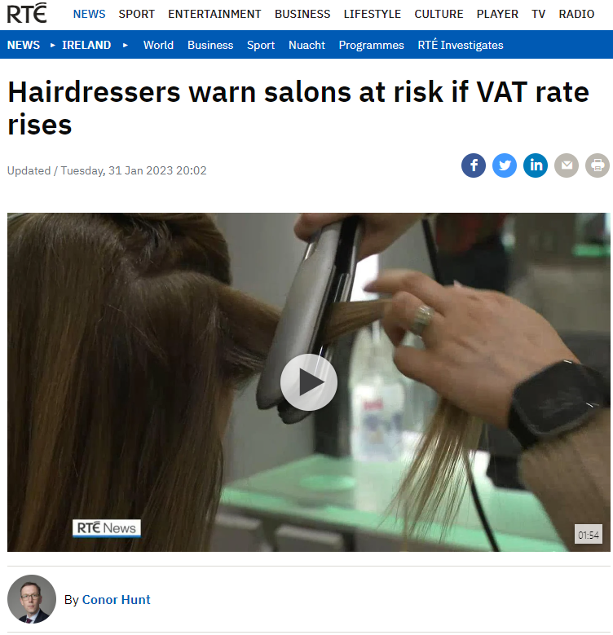
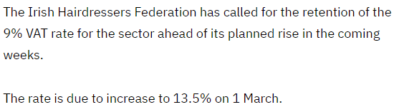
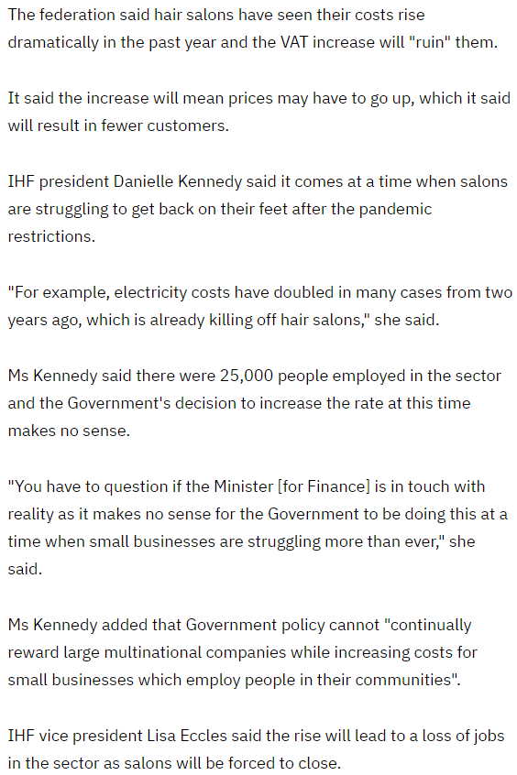

Publication: RSVP Live
Section: Irish News
Date: 31 January 23
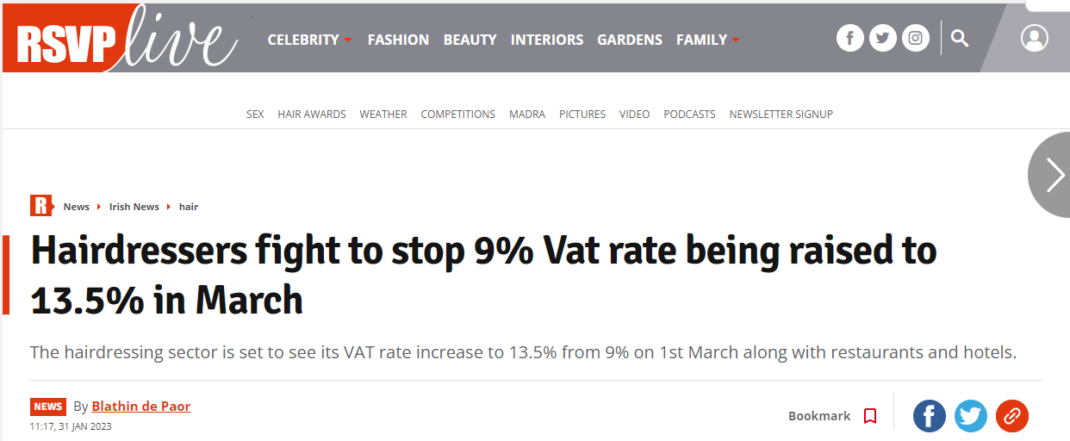
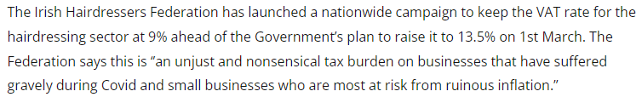
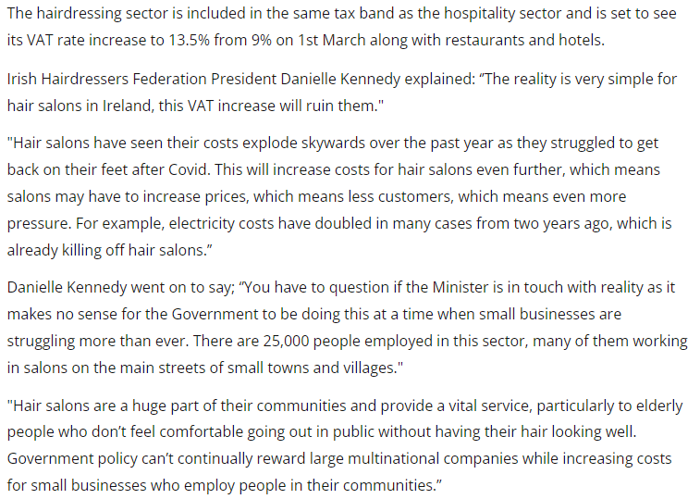

Publication: Limerick Live
Section: National News
Date: 31 January 23
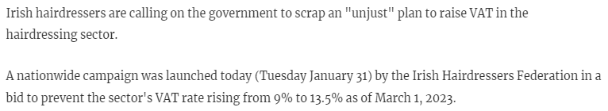

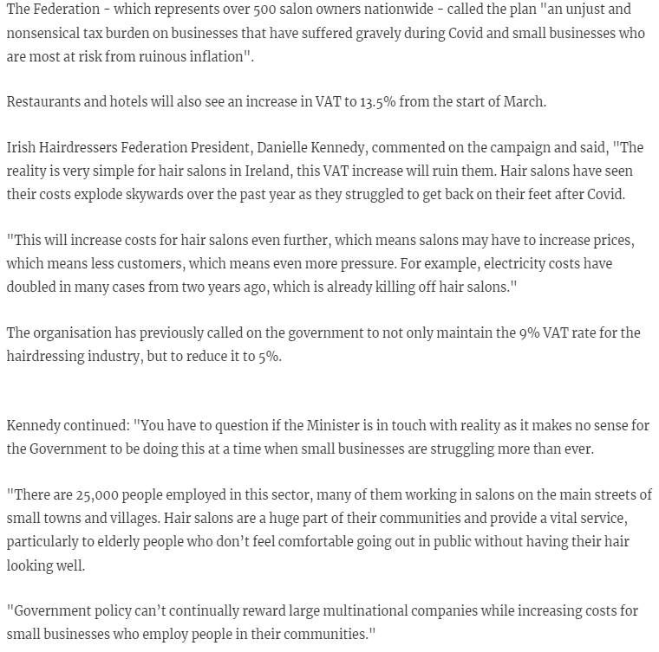

Publication: Kildare Live
Section: News
Date: 31 January 23

Publication: HiStyle.ie
Section: News
Date: 31 January 23
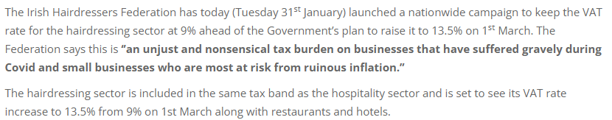

Publication: BusinessCork.ie
Section: News
Date: 31 January 23

Publication: Business Island
Section: News
Date: 31 January 23

Publication: Red FM Online
Section: News
Date: 31 January 23
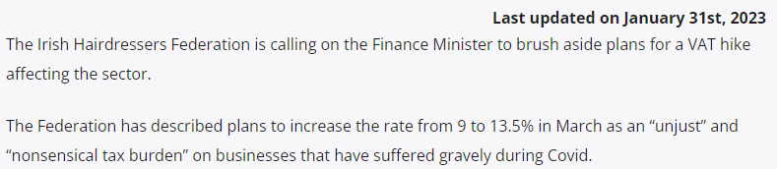
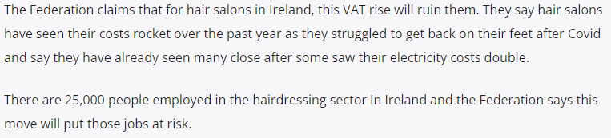

Publication: BreakingNews.ie
Section: News
Date: 31 January 23
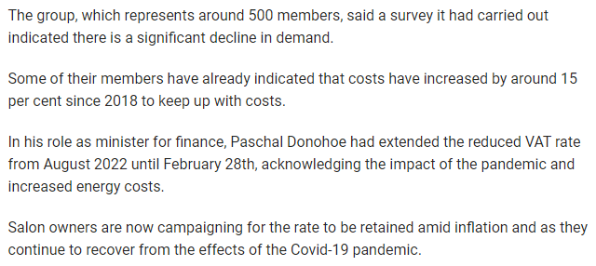
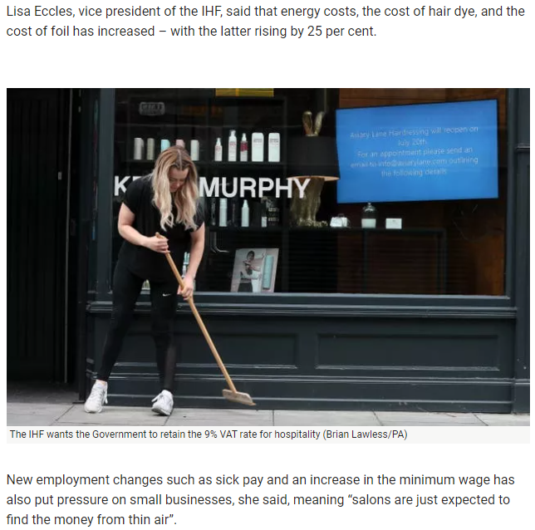
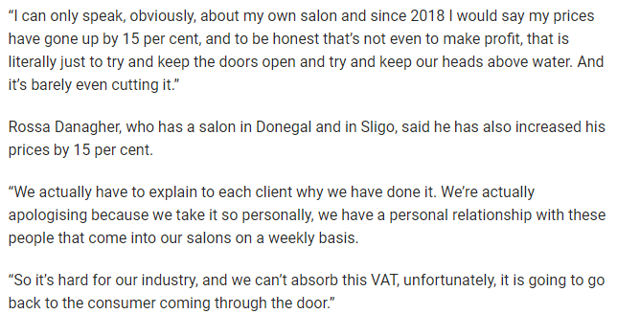
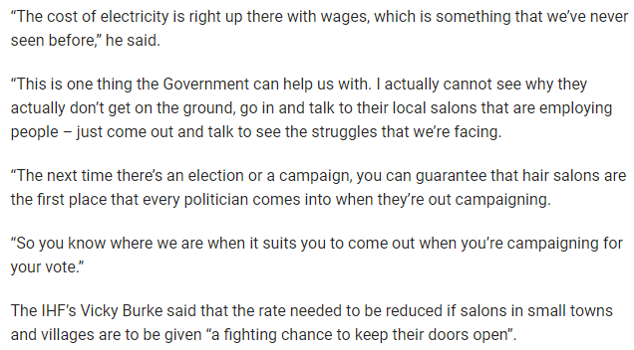
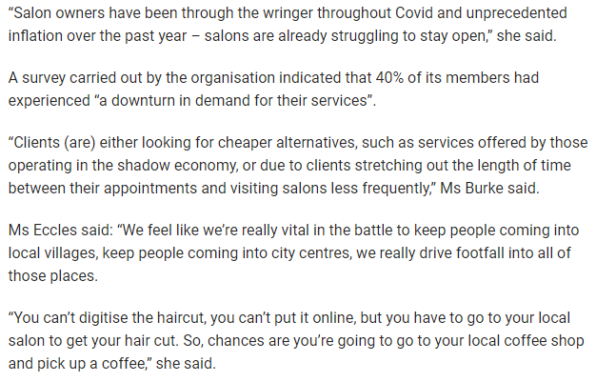

Publication: FM 104 Online
Section: News
Date: 31 January 23

Publication: The Journal
Section: News
Date: 31 January 23
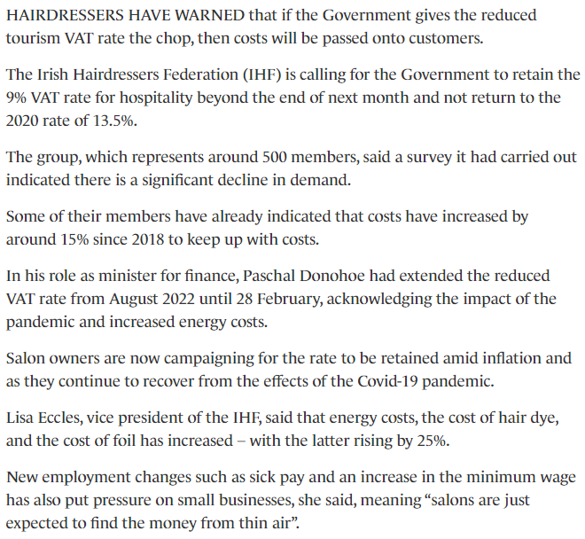
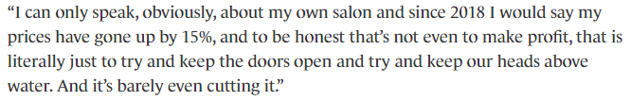
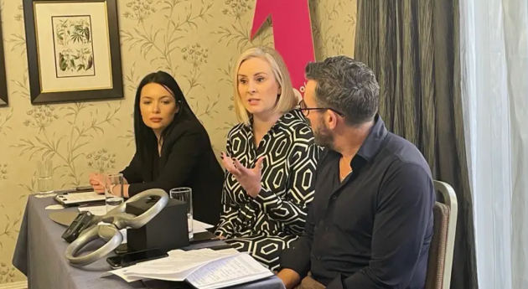
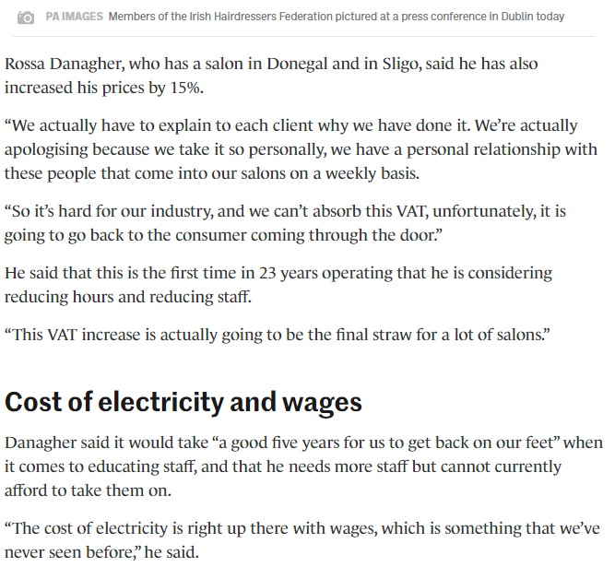
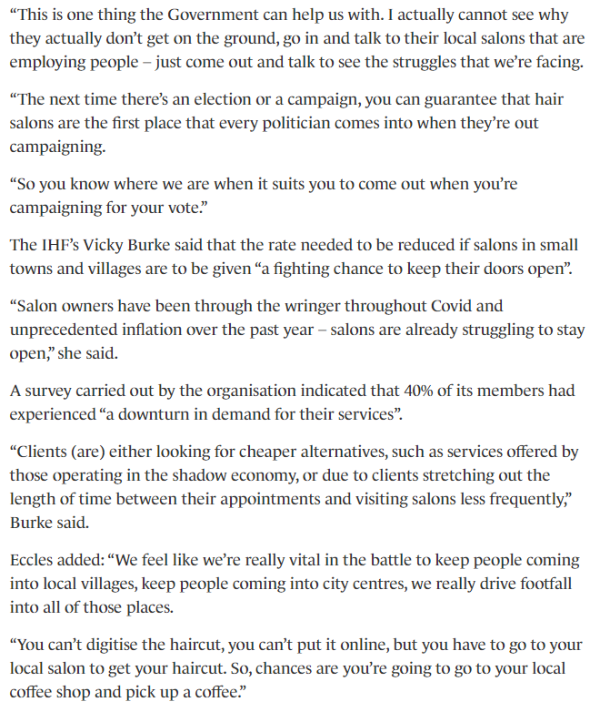

Publication: 98 FM Online
Section: News
Date: 31 January 23
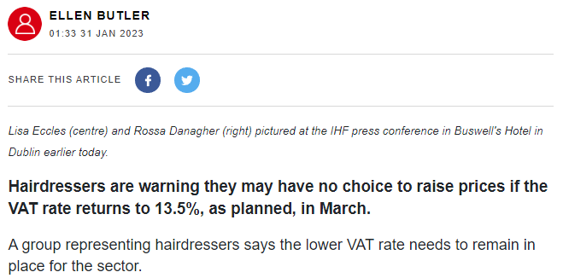
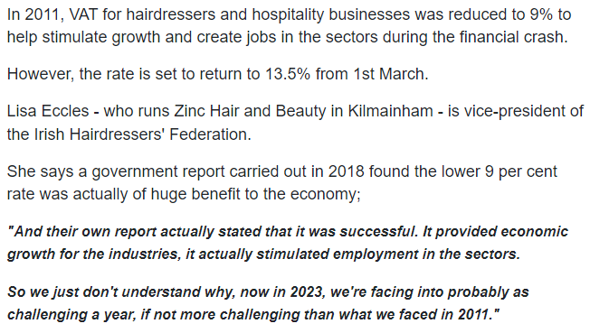
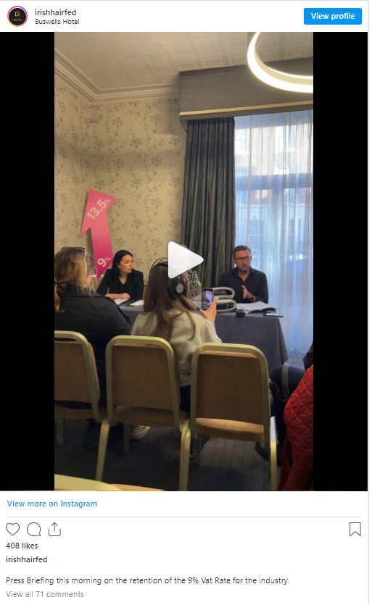
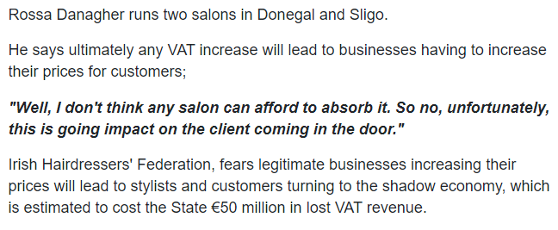

Publication: Kilkenny Live
Section: News
Date: 31 January 23
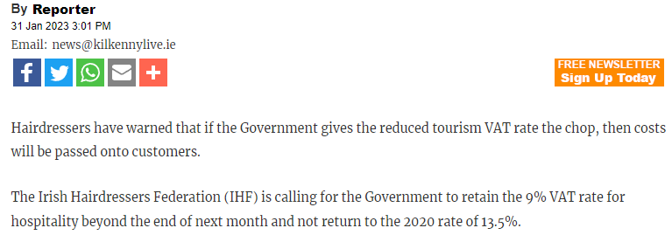
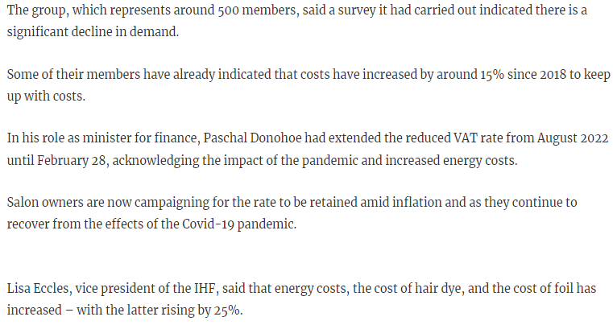
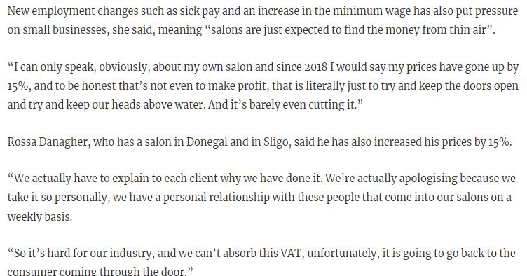
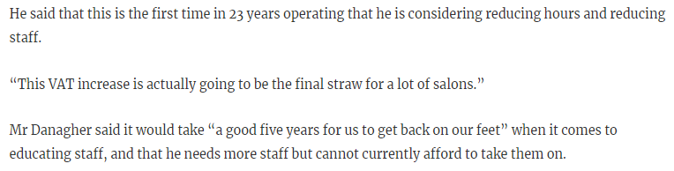
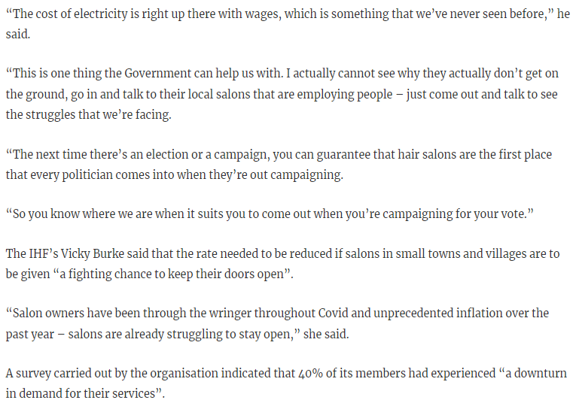
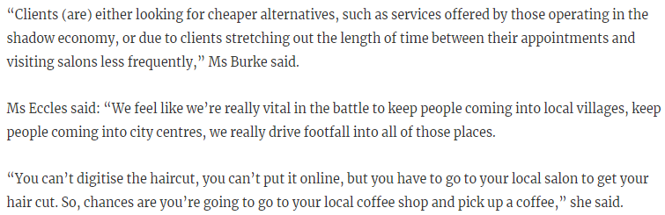

Publication: The Irish Times Online
Section: Ireland
Date: 31 January 23
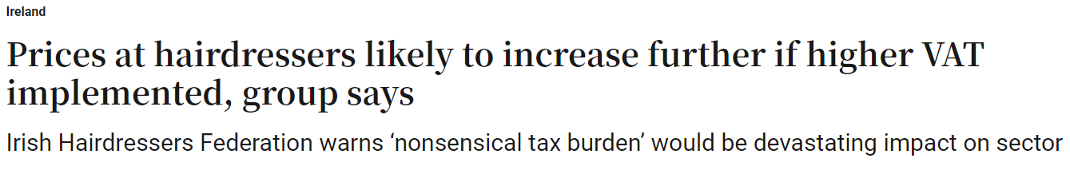
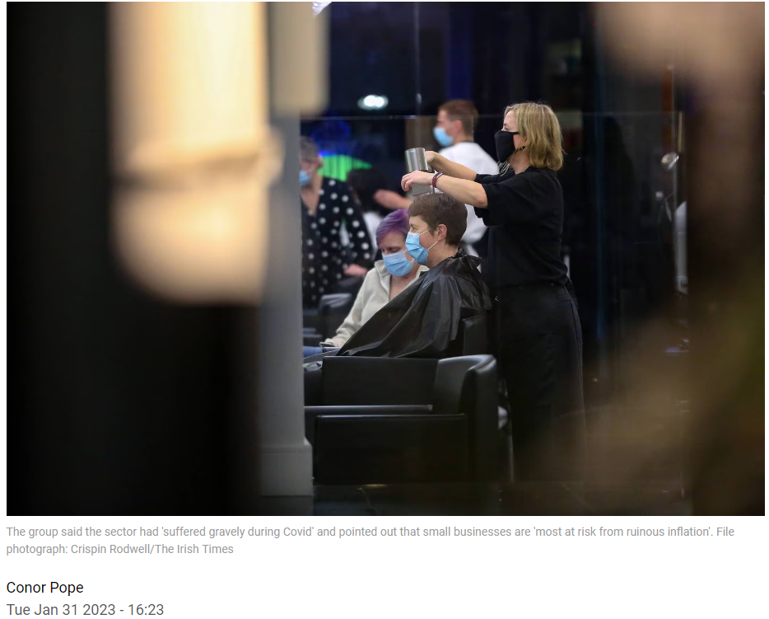
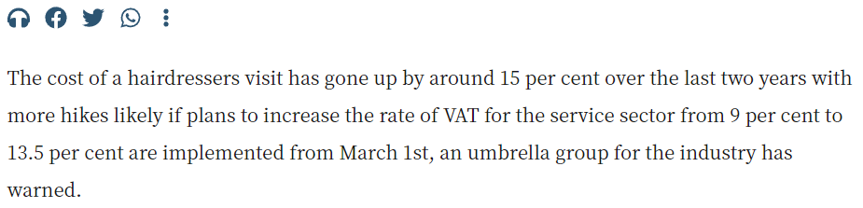
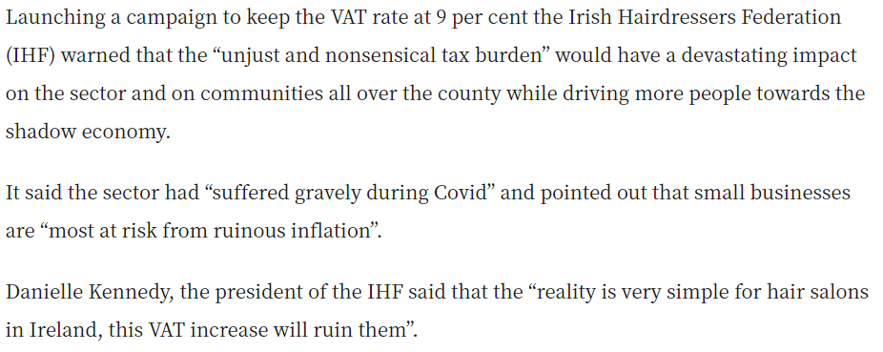
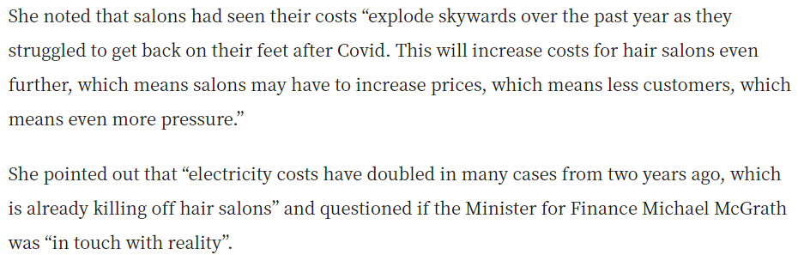

Publication: RTÉ One
Section: RTÉ News: Six One
Date: 31 January 23

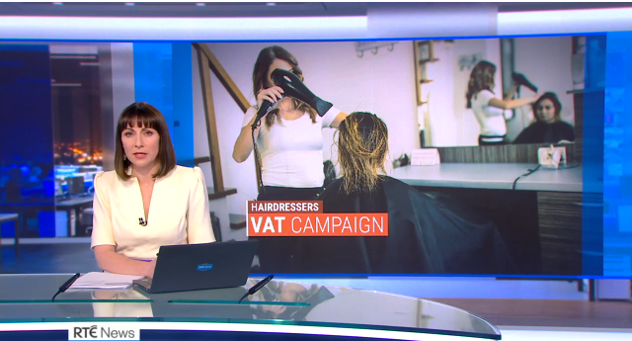

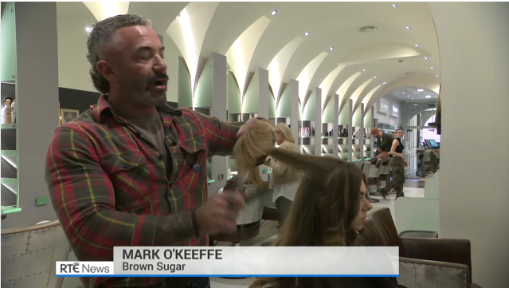

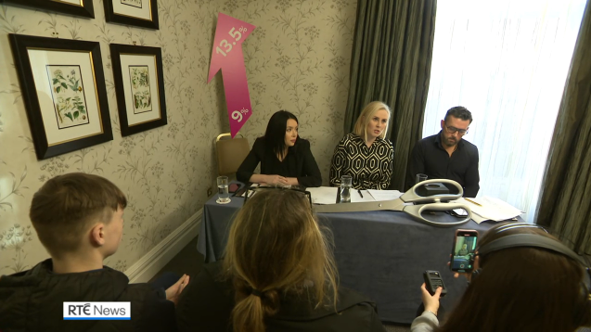

Publication: WLR FM
Section: Déise Today
Date: 31 January 23

Lisa Eccles was on air with Damien Tiernan on WLR FM on Tuesday 31st January.

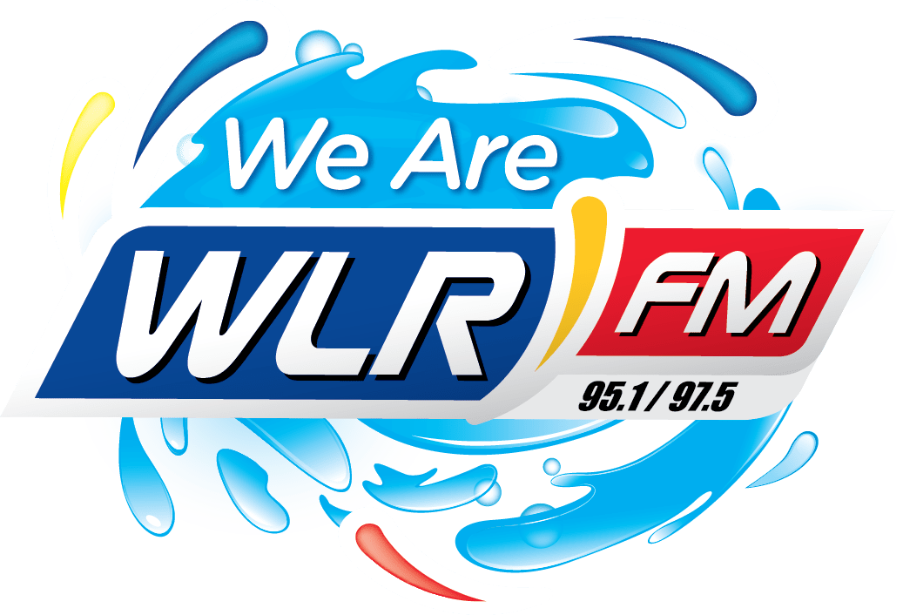

Publication: Irish Daily Mail
Section: News
Date: 1st February 23

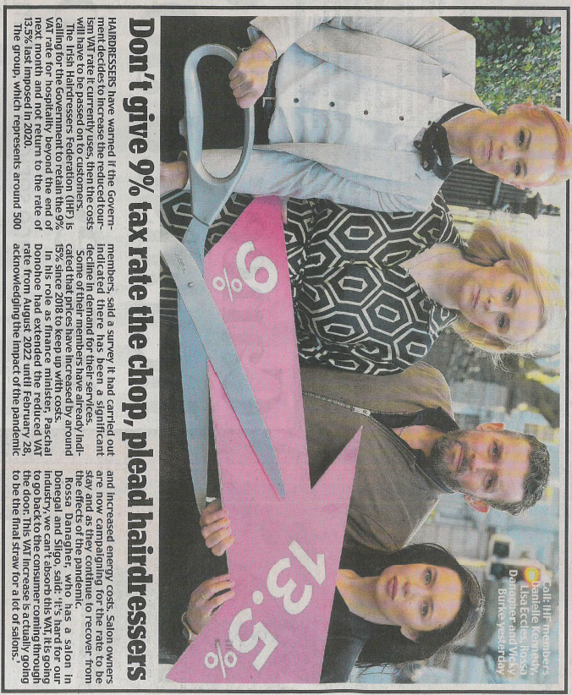

Publication: Irish Sun
Section: News
Date: 1st February 23

Publication: Irish Daily Star
Section: News
Date: 1st February 23
